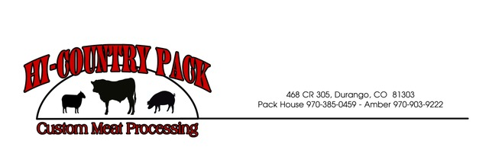

**BEEF CUT SHEET** service@hi-countrypack.com

Drop date:________________ Kill date:_________________ Cut date:_________________ Pick up date:____________________

**Customer:** **Producer:**

Name:__________________________________________________ Name:_____________________________________

Address:________________________________________________ Phone:_____________________________________

Phone#:_________________________________________________ Tag#/Desc:_________________________________

BRAND

**WHOLE / HALF / QTR**

*(add $25 for each quarter and single steaks wrap $25 per half)*

*Butchers cut: Steaks 3/4” / Roasts 2.5lbs / Hamburger 1.5lb (this is recommended and will default if not filled in)

**Thickness #/pkg or lbs or Ground to Burger**

Round Steak or tenderized __________

Sirloin Steak……………............ 1/2in 3/4in 1 in 1 2 3 _____ T-Bone ……………………..………. 1/2in 3/4in 1 in 1 2 3 _____

Rib Steak ………………………….. 1/2in 3/4in 1 in 1 2 3 or Rib Roast _____

Flank Steak (1per1/2)………… ½ in _____1_______ _____

Skirt Steak (1per1/2)………….. ½ in _____1_______ _____

Tip Steak ……………………………. 1/2in. 3/4in 1in 1 2 3 or Tip Roast _____

Chuck Roast………………………....................................... *3-4lbs each* _____

Arm Roast………………………………………………………………. *3-4lbs each* _____

Rump Roast…………………………………………………............ *3-4lbs each* _____

Short Ribs……………………………………………………………….. 4-5 per pkg____ _____

Hamburger………………………………………………………………  **1lb 1.5lbs 2lbs**

Stew Meat………………………………………………………………. 1 pound packages_____

Brisket..…………………………………………………………………...**whole / cut in half**

**Hanging Weight______________**

This beef is not USDA inspected…Not for Resale. Private consumption only.

Additional charges may apply if meat is not picked up on scheduled date.

**Thank you for your Business!!**

**Comments:**___________________________________ Kill Price **$90/hd** x_________ hd= ________________

____________________________________________ Cut Price **.90¢/lbs** x__________ lbs= ________________

____________________________________________ Single wrap extra charge/ Misc charges = ________________

____________________________________________

Pd: Cash / Ck#______________

**TOTAL DUE _______________**